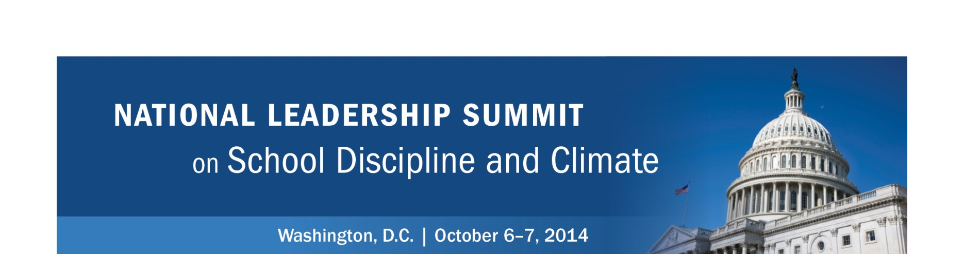

DATA PACKETS

Each team received a packet of materials on its table with data summaries for its state, or districts within its state, across a series of data collections. The same data are included on the flash drive that participants received at the start of the summit. These data summaries are drawn from the following collections:

Civil Rights Data Collection (CRDC)
OFFICE FOR CIVIL RIGHTS, U.S. DEPARTMENT OF EDUCATIONhttp://ocrdata.ed.gov/

The CRDC collects data on key education and civil rights issues in our nation's public schools for use by the U.S. Department of Education's Office for Civil Rights (OCR), other Department of Education offices, and other policymakers and researchers. This data collection provides information about students in public elementary and secondary schools on a variety of indicators, including enrollment, access to educational programs or services, and academic proficiency results. The information is disaggregated, or broken out, by factors including race, ethnicity, sex, and disability. Data included in this packet highlight measures related to discipline and arrests.

OJJDP Data Collection
OFFICE OF JUVENILE JUSTICE AND DELINQUENCY PREVENTION
http://www.ojjdp.gov/ojstatbb/default.asp

OJJDP collects a variety of data focused on both juvenile crime and victimization, and youths involved in the juvenile justice system. The National Center for Juvenile Justice (NCJJ) has developed a statistical briefing book, which enables users to access online information via OJJDP's website to provide timely and reliable statistical information. The profiles in this packet provide a quick snapshot of state and national juvenile populations, juvenile victims, arrests, and youths in corrections, as well as national profile maps.

OSEP Data Collection
OFFICE OF SPECIAL EDUCATION PROGRAMS
http://www.ideadata.org/

The OSEP data collection is maintained by the Data Accountability Center (DAC). Federal data for each state are collected annually by state in relation to the Individuals with Disabilities Education Act (IDEA), Parts B and C. Areas of data collection include educational environments, discipline, student assessment, dispute resolution, and students’ exiting programs. These data are collected by disability category, race/ethnicity, gender, and limited English proficiency (LEP) status at the state education agency, local education agency, and school levels. The profiles in this packet are aggregate national-level data, so every state team has the same dataset.

Title I, Part D, Data Collection
OFFICE OF ELEMENTARY AND SECONDARY EDUCATION
http://www.neglected-delinquent.org/fast-facts/united-states

The National Evaluation and Technical Assistance Center for the Education of Children and Youth who are Neglected, Delinquent, or At-Risk (NDTAC) prepares State Fast-Facts Pages for the U.S. Department of Education and grantees of the Title I, Part D, Subpart 1, State Agency Programs. Fifty states, along with Puerto Rico and the District of Columbia, receive funds under Subpart 1. The longitudinal data provided on these pages highlights grantees’ funding, student demographics, and key academic outcomes for children and youths who are neglected or delinquent and enrolled in these programs. The four key academic outcomes featured also are used to track Title I, Part D, program performance and are of particular importance to grantees and the U.S. Department of Education.

YRBS Data Collection
THE YOUTH RISK BEHAVIOR SURVEY
http://www.cdc.gov/healthyyouth/yrbs/factsheets/index.htm

The Youth Risk Behavior Survey (YRBS) is administered through the Centers for Disease Control and Prevention. Results from the survey provide data on health-risk behaviors among ninth- through 12th-grade students in the United States, including behaviors that contribute to injuries and violence, alcohol or other drug use, tobacco use, sexual risk behaviors, unhealthy dietary behaviors, and physical inactivity. YRBS also measures the prevalence of obesity and asthma among youths and young adults. The profiles in this packet present the trends in the prevalence of behaviors that contribute to violence on school property as well as national profile maps for the most current year available.

