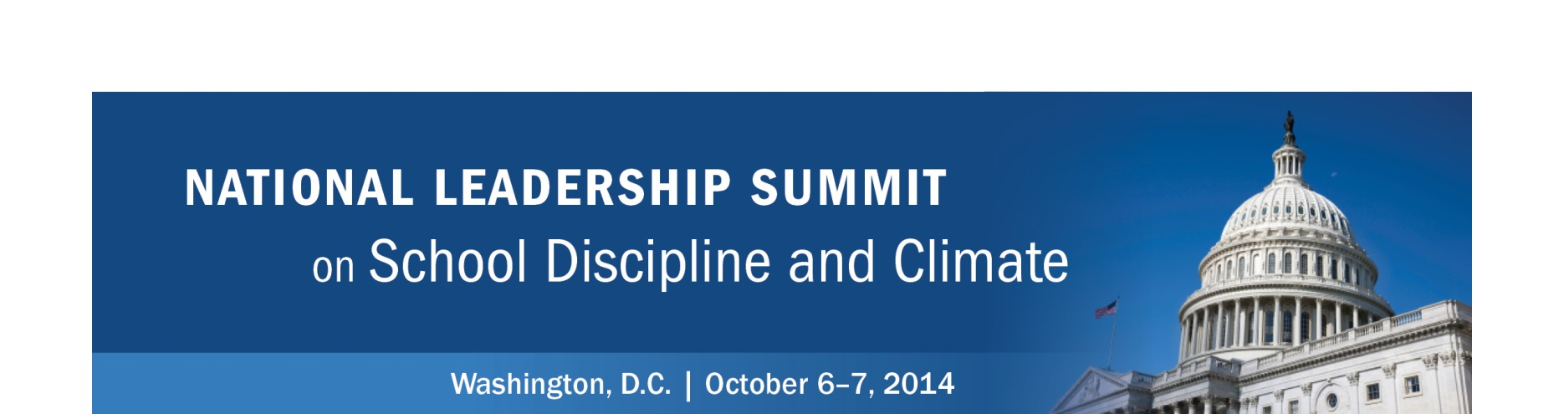

Facilitated Strategy Session #4: 2014–16 Action Plan

Based on what you have heard in each topical breakout session and your team discussions, review your initial plans and come to consensus on your state and/or community action plan.

 | What can be done immediately? | What can be done during the 2014–15 school year? | What can be done in preparation for the 2015–16 school year?
Political Will
(Pages 13–14)
Funding and Policies
(Pages 17–18)
Cross- Systems Collaboration
(Pages 20–21)
Practices (Pages 16, 19)

